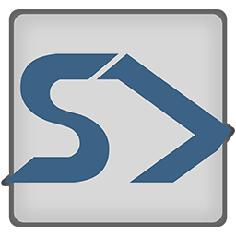

START

Smart Train Application for Route Testing

*For Version 2.1+*

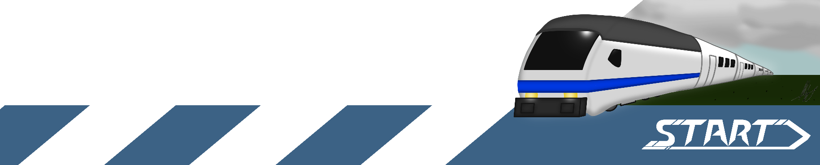

Manual author: [*M.Metsola*](https://github.com/RisenOutcast) *&* [*J.Liimatainen*](https://github.com/jliima)

**Contents**

Functions 3

Route Editor View 3

Train Editor View 4

Simulation View 5

Settings View 6

Quick How-to-Guide 6

Info 6

Creating route 7

Adding stops 8

Modifying Route 9

Adding tunnel 10

Adding train 11

Editing existing train 11

Simulation and playback 12

## Functions

Here is a basic rundown of all the features of the application.

Different views can be switched at the top left corner of the application.

### Route Editor View

1. **Route drop down**: Switch between available routes.
2. **Add Route button**: Allows user to add a new route.
3. **Modify Route button**: For editing the route and its features.
4. **Add Tunnel button**: Opens tunnel adding interface.
5. **Add Stops button**: Opens stop adding interface.
6. **Confirm button**: Confirms current action, e.g. adding route, tunnel, or stops. (Note that naming stops doesn’t require pressing this).
7. **Cancel button**: Confirms current action, e.g. adding route, tunnel, or stops.
8. **Current Action**: Indicates which action is currently being performed.
9. **Stops**: Editable name fields for the stops. Selecting will highlight stop on map.
10. **Save all**: Saves all routes and trains.
11. **Export**: Export the current route as a file.
12. **Help**: Opens this guide.

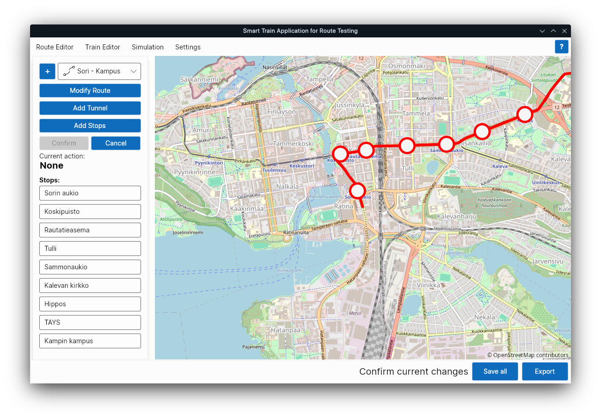

### Train Editor View

1. **Train drop down**: Switch between available trains.
2. **Add Train button**: Allows user to add a new train.
3. **Edit button**: Allows user to edit currently selected train.
4. **Cancel button**: Cancels current operation (adding or editing a train).
5. **Train information**: Displays information for currently selected train.
6. **Save all**: Saves all routes and trains.
7. **Export**: Export the current route as a file.
8. **Help**: Opens this guide.

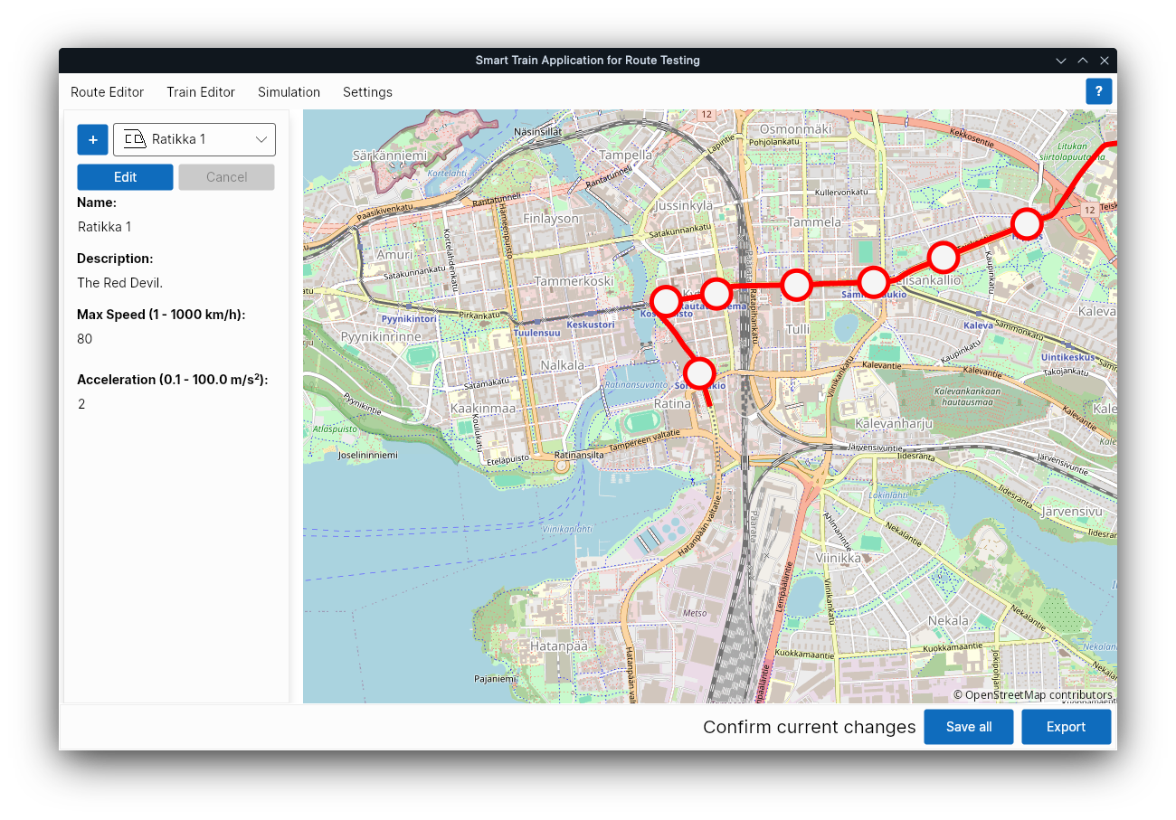

### Simulation View

1. **Route drop down**: Switch between available routes.
2. **Train drop down**: Switch between available trains.
3. **Tick length**: 1 second by default. If increased the time between each tick is longer → making the simulation faster, if decreased makes the simulation have more ticks → slows down the simulation. NOTE! decreasing this value is not tested!
4. **Create Simulation button**: Creates simulation file in the simulation directory defined in the application settings.
5. **Play button**: Plays simulation animation. Becomes available after a simulation is created by clicking “Create Simulation”.
6. **Stops**: List of stops available in the route. Selecting will make train wait on the stop.
7. **Save all**: Saves all routes and trains.
8. **Export**: Export the current simulation as a file.
9. **Help**: Opens this guide.

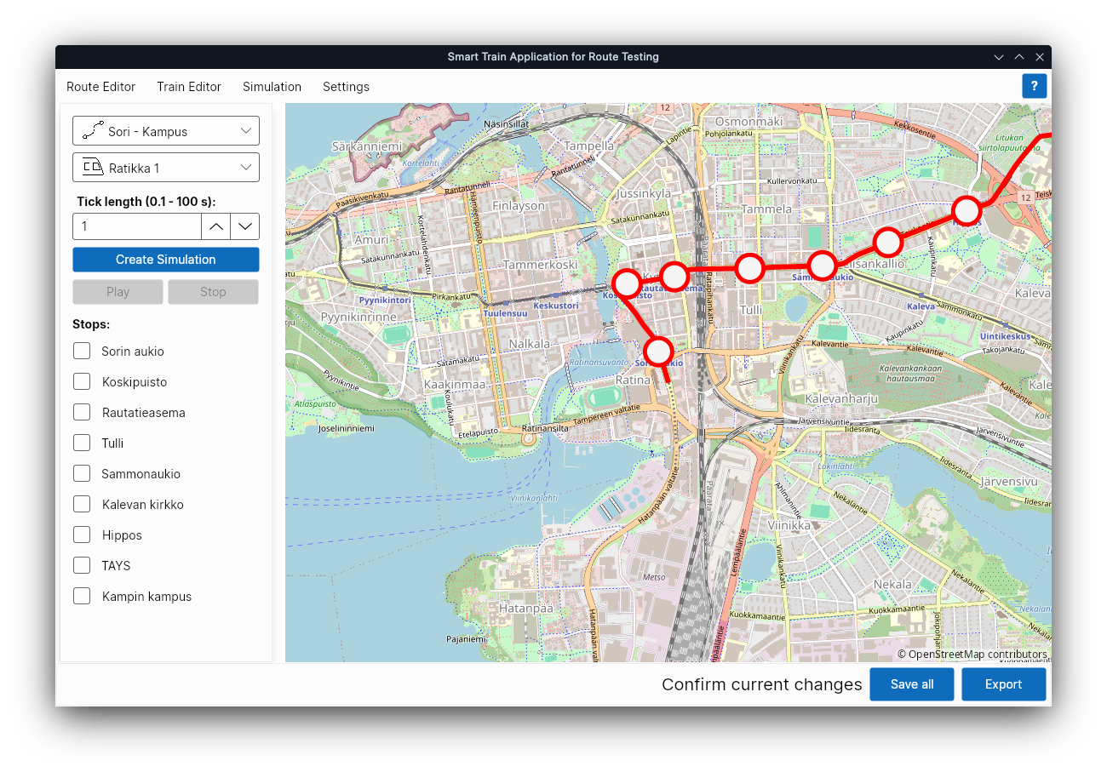

### Settings View

1. **Default location**: The coordinates that will be loaded on the map when the program starts.
2. **Route import directories**: List of directories, one per line, that will be used to import and save routes to/from. NOTE! Currently only the first one is actually used.
3. **Train import directories**: List of directories, one per line, that will be used to import and save trains to/from. NOTE! Currently only the first one is actually used.
4. **Simulation directories**: List of directories, one per line, that will be used to import and save simulations to/from. NOTE! Currently only the first one is actually used.
5. **Save button**: Saves current settings in the *settings.json* file.
6. **Reset button**: Resets settings to their default values.

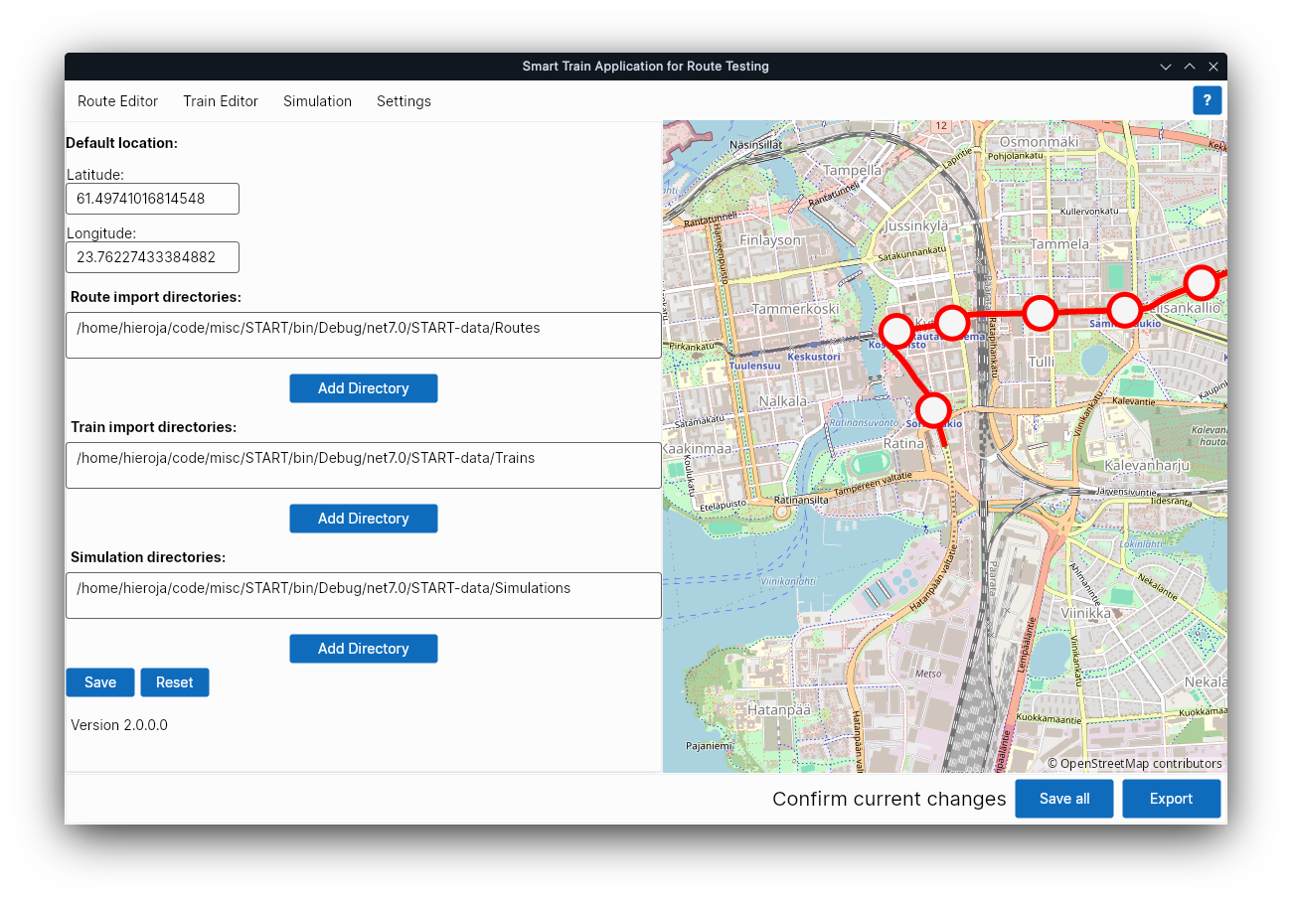

## Quick How-to-Guide

### Info

This tool can be used to create routes, trains and generate simulated data for the train moving through the route.

### Creating route

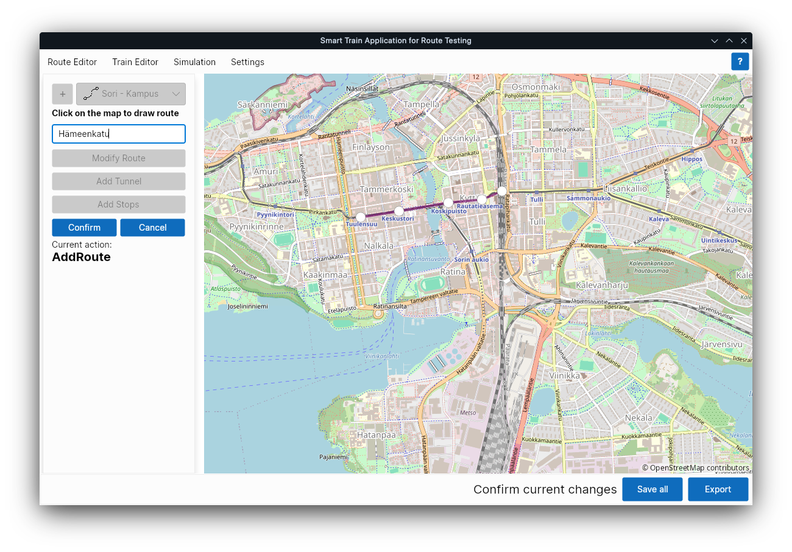Route Editor – adding route.

1. Navigate to the **Route Editor** view.
2. Click the **+** button.
3. Insert route name to the nave input field.
4. Click on the map to draw the route from start to finish. These points can be edited later.
5. Click on **Confirm**.
6. The new route will be available in the program.
7. To save the newly created route to the route folder, click **Save all**.
8. To export the newly created route to any other folder, click **Export**.

### Adding stops

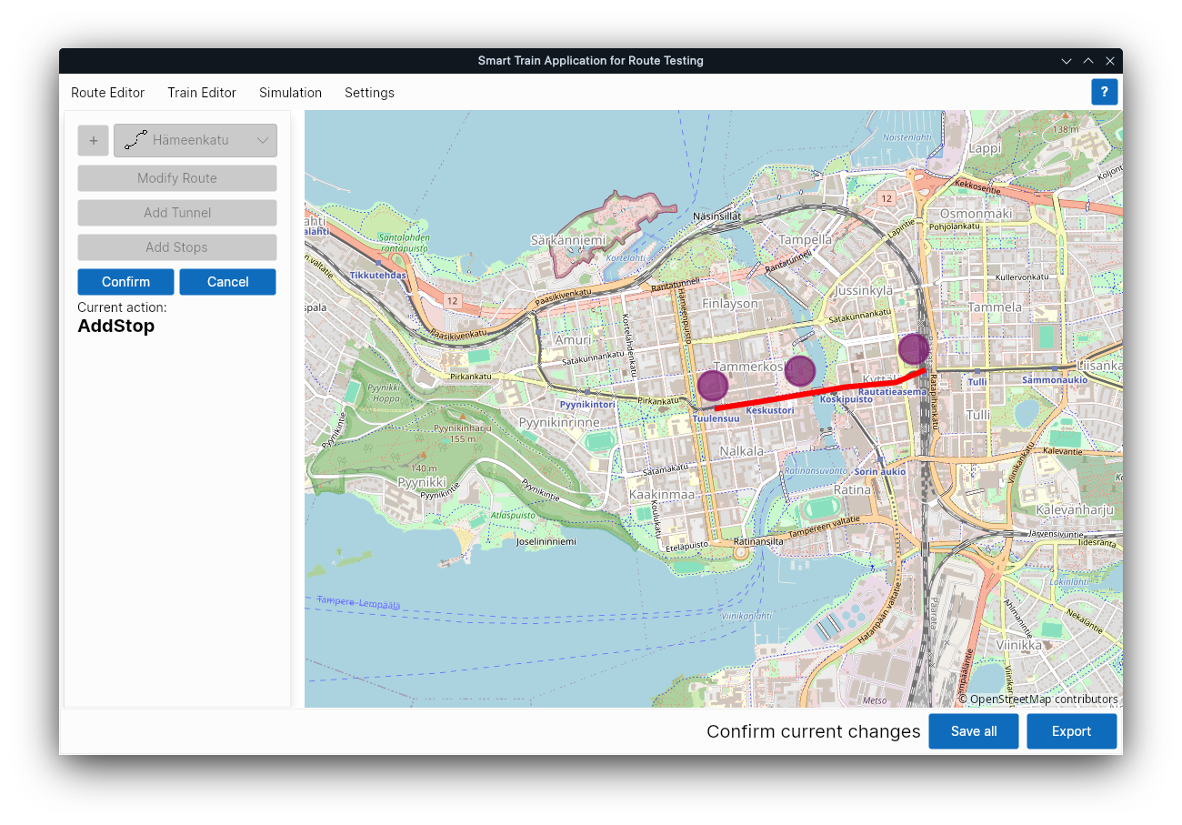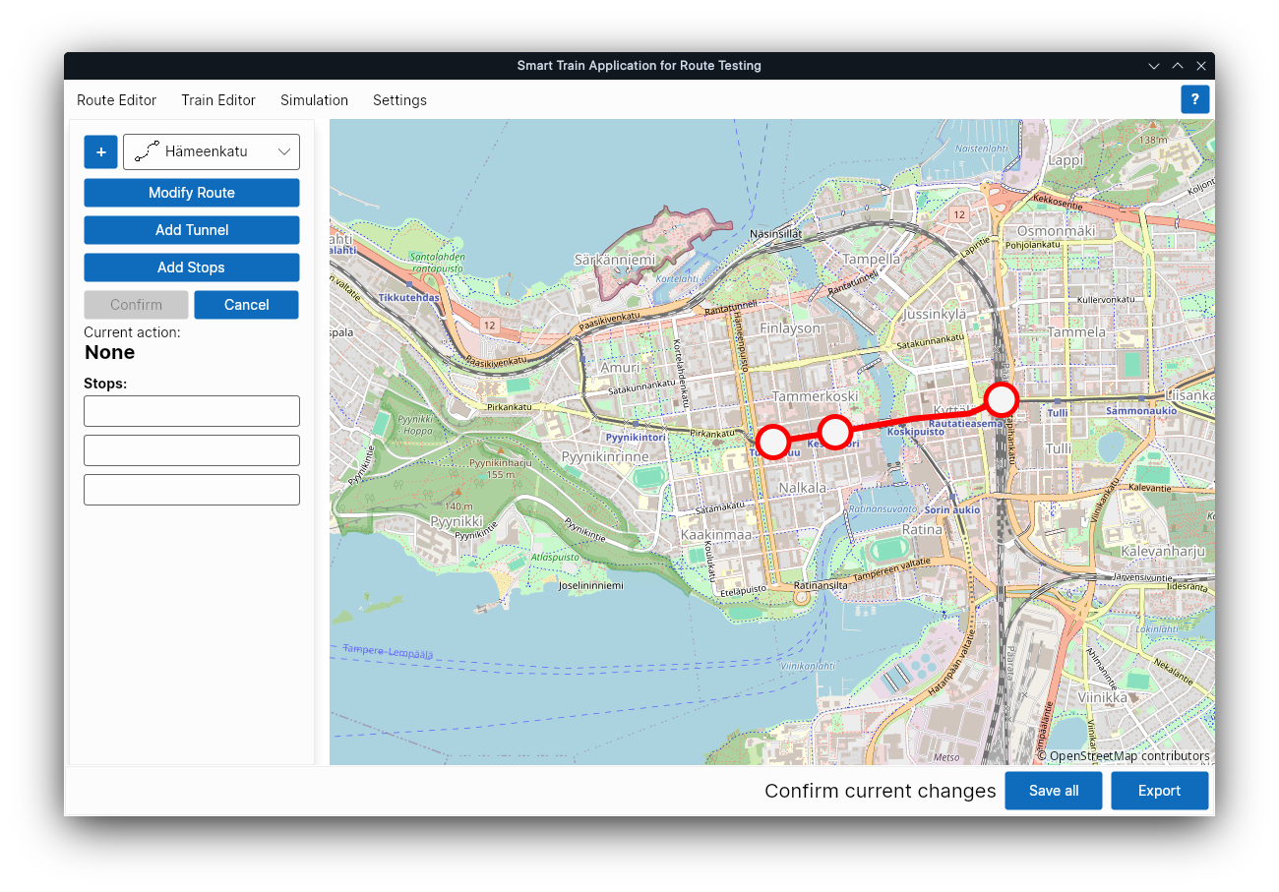Route Editor – adding stops.

1. Click **Add Stops**.
2. Click close to the points you want the stops to be added. The stops will be added to the closest route defining dot afterwards.
3. Purple circles appear.
4. Click **Confirm**.
5. New stops will appear on the route and empty name fields will be come visible.
6. Name the stops by clicking on the empty fields. Activating a name field will highlight corresponding stop on the map.
7. To save the newly created stops to the route, click **Save all**, this updates the route json-file in the route directory.
8. To export the route with the created stops to any other folder, click **Export**.

### Modifying Route

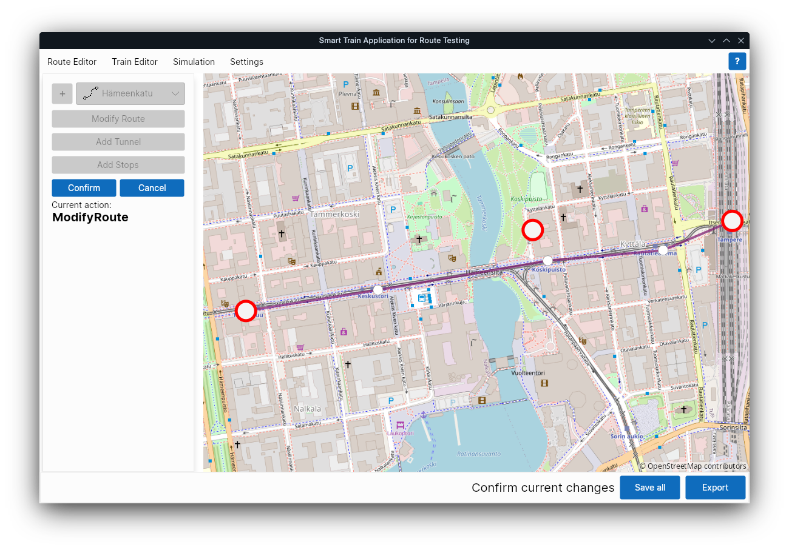Route Editor – modifying route.

1. Click **Modify Route**.
2. The route will become editable.

In this mode, the user can move the route defining points and stops. Moved stops will attach to the closest route point when pressing **Confirm**.

START will automatically rearrange the stops if the user changes their order in the map.

To add new route defining point, left click on the route line, new route point will appear.

### Adding tunnel

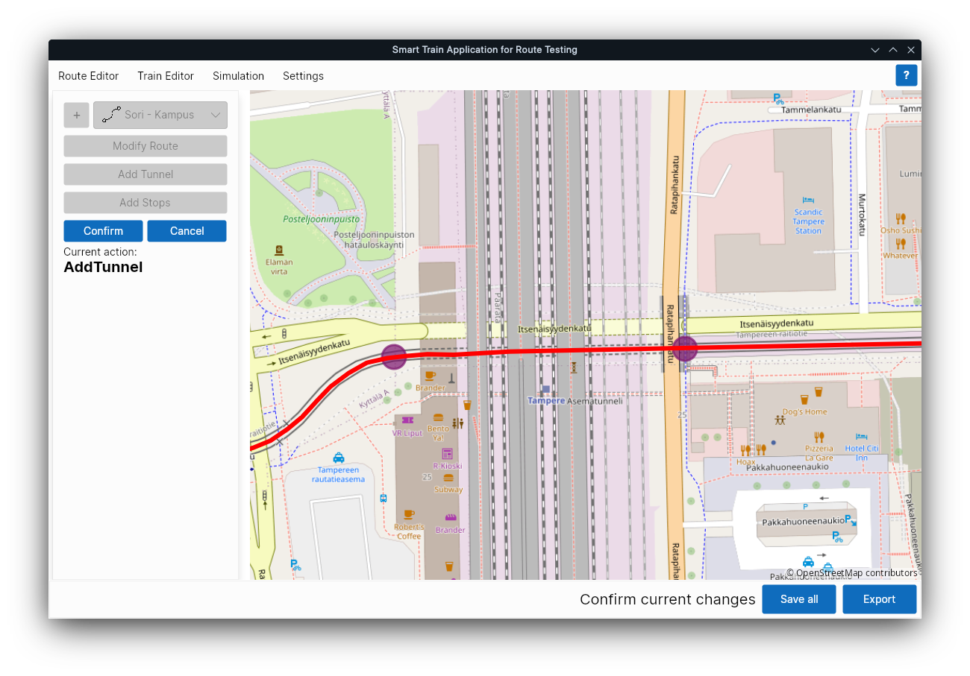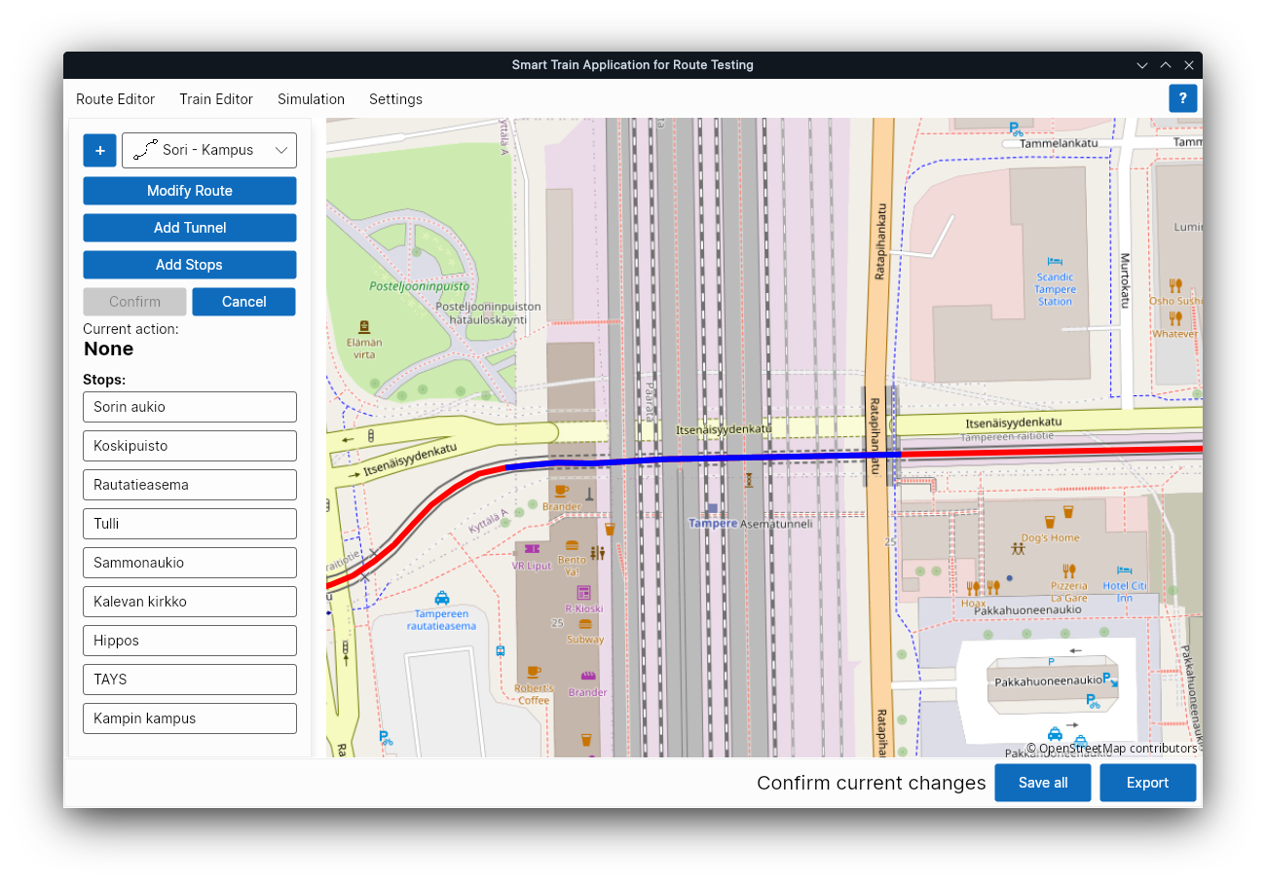Route Editor – adding tunnel.

1. Click **Add Tunnel**.
2. Click two times on the route, first click inserts the first tunnel entrance, second inserts the second tunnel entrance.
3. Click **Confirm**.
4. The tunnel will be show on the route as blue section.
5. To save the newly created tunnel to the route, click **Save all**, this updates the route json-file in the route directory.
6. To export the route with the created tunnel to any other folder, click **Export**.

### Adding train

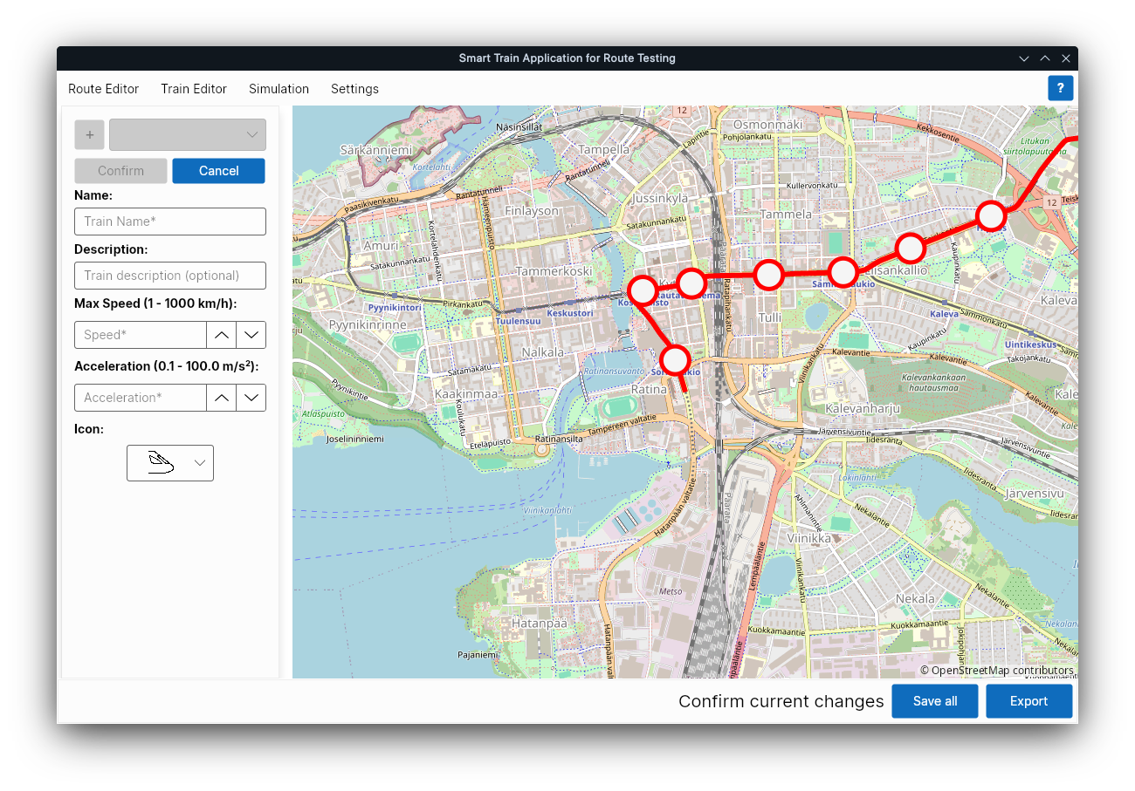Train Editor – adding train.

1. Navigate to the **Train Editor** view.
2. Click on the **+** button (if no trains have been created, the editing mode will be already selected by default).
3. Fill in the **Name**, **Max Speed**, **Acceleration** and optionally **Description** and **Icon**.
4. Once all the required fields are filled, the **confirm** button will become available.
5. Click **Confirm**.
6. To save the newly created train, click **Save all**, this creates json-file to the trains directory.
7. To export the train to any other folder, click **Export**.

### Editing existing train

1. Navigate to the **Train Editor** view.
2. Select a train to be edited from the drop down menu.
3. Click **Edit** to display the editing fields.
4. Edit the fields and click **Confirm**.
5. To save the edits to the train, click **Save all**, this updates the existing train json-file in the trains directory.
6. To export the train to any other folder, click **Export**.

### Simulation and playback

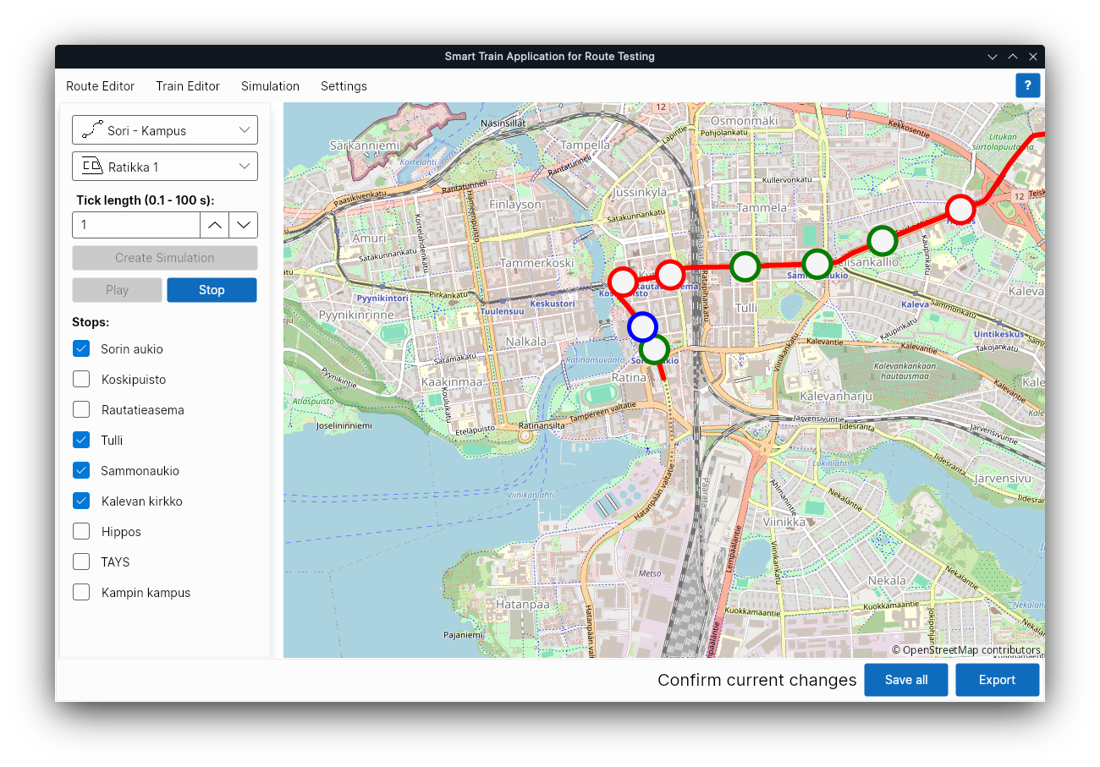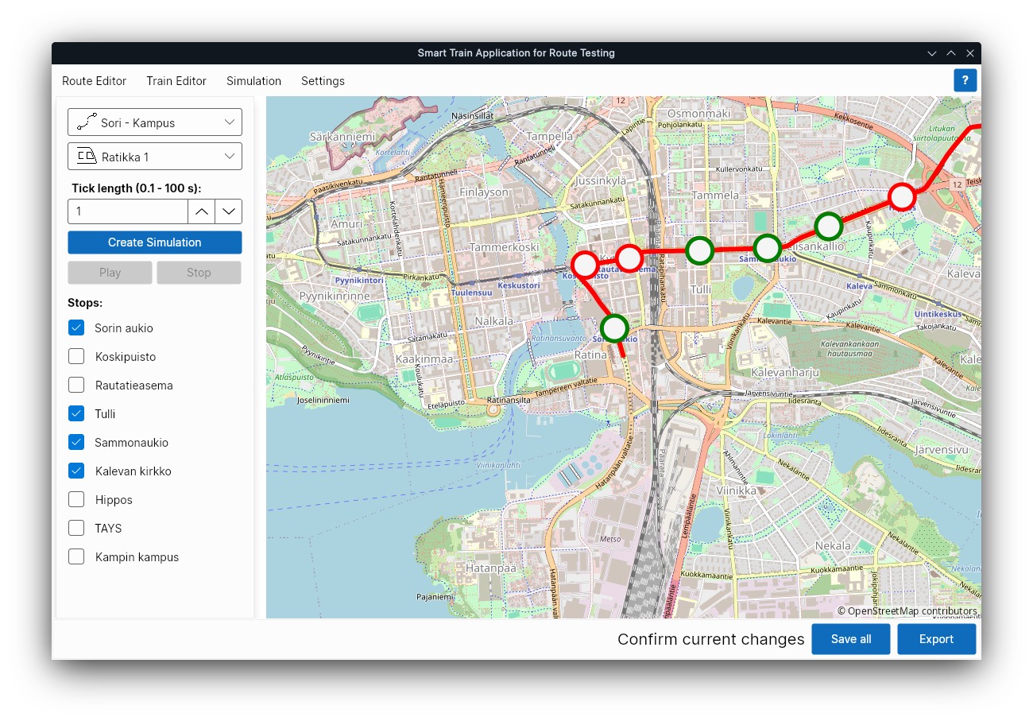Simulation view – creating and running.

To create a simulation json-file:

1. Select train and route from the drop down menus.
2. Optionally increase the Tick time interval, this speeds up the simulation by decreasing the amount of generated ticks.
3. Select on what stops the train will be stopping at by clicking on the checkboxes.
4. Press **Create Simulation**.
5. A json file containing the tick data will be created to the simulations folder.
6. To export the simulation json to any other folder, click **Export**.

To play the simulation on the map, click **Play** after creating the simulation file.